**Use Case Diagrams**

Figure 1- User makes an account.

Actor: User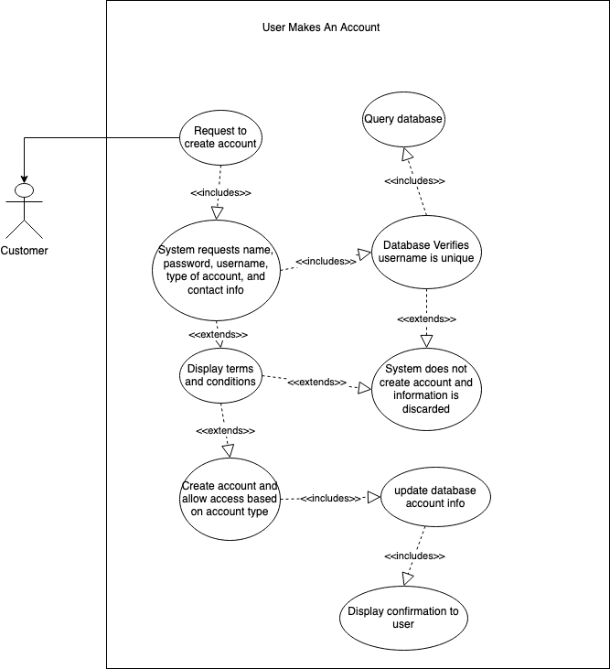

Entry Conditions:

User wants to create an account

Exit Conditions:

Account is created

User rejects terms and account is not created

Event Flow:

* 1. User requests to create account
  2. System requests Username, password, email address, phone number, address, and account type
  3. System displays terms and conditions
     1. If User accepts, account is created
     2. If User declines, account is not created

Figure 2- User updates account

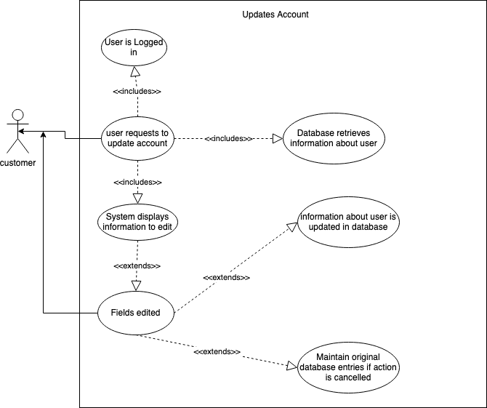

Participating Actor: User

Entry Conditions:

User is logged in

Exit Conditions:

User Cancels action

User account is updated

Event Flow:

* 1. User requests to update account
  2. System displays account features to edit
  3. User edits fields
     1. If User saves, the account is updated
     2. If User cancels, the account is not updated

Figure 3- Customer Posts a Job

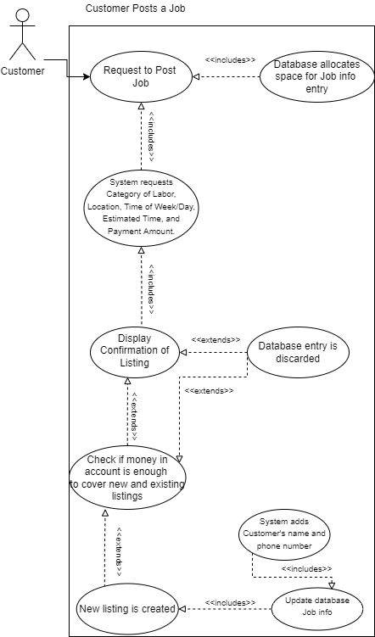

Participating Actor: Customer

Entry Conditions:

Customer is logged in

Customer wants to post a new job

Exit Conditions:

Customer cancels action

Customer post a job

Customer doesn’t have enough money in account

Event Flow:

* 1. Customer requests a new job listing
  2. System asks Customer to provide the category of labor, Location, Time of week/day, Estimated time, and how much they are willing to pay.
  3. Customer fills in appropriate fields.
  4. System fills in Customers name and phone number
  5. System displays confirmation of listing
     1. If Customer submits the job listing, new listing is added to the database
     2. If Customer doesn’t submit, the job is not listed
     3. If Customer doesn’t have enough money System asks if they want to add more money.
        1. If Customer adds more money, the job is listed
        2. If Customer doesn’t add more money the job is not listed

Figure 4- Worker Looks for and Accepts a Job

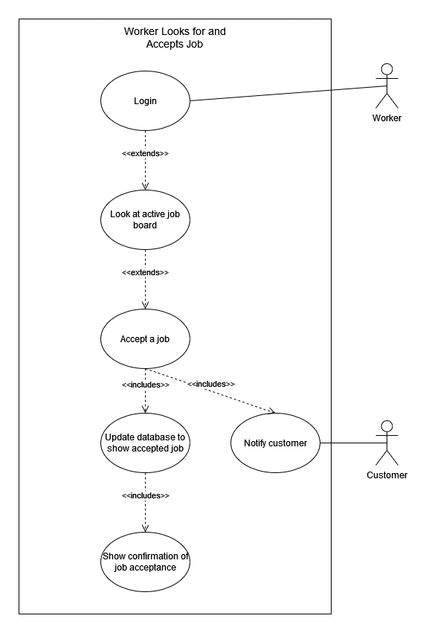

Participating Actor: Worker

Entry Conditions:

Worker is logged in

Worker is looking for a new Job

Exit Conditions:

Worker Accepts a New Job

Event Flow:

* 1. Worker Looks at Active Job board
  2. Worker Accepts a Job
  3. System Updates that Worker Accepted the job in database
  4. System Sends notification to Customer
  5. System displays confirmation of Acceptance

Figure 5- Customer Accepts Worker for a Job

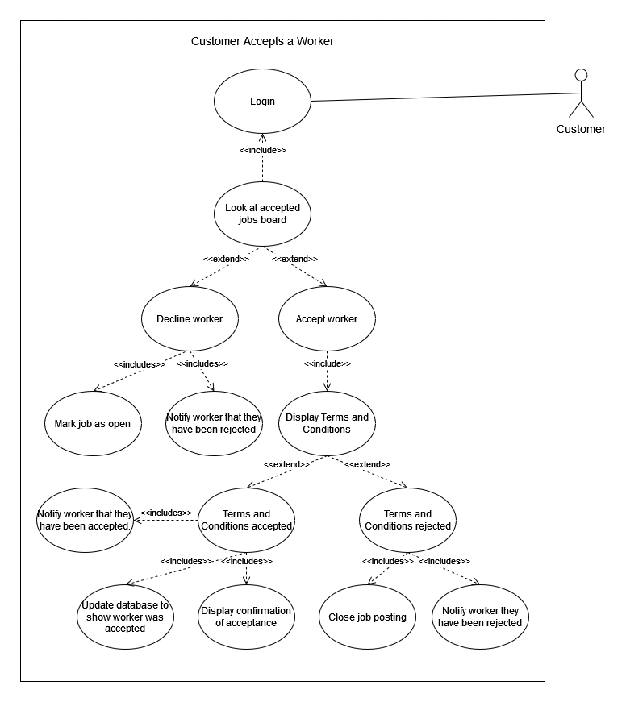

Participating Actor: Customer

Entry Conditions:

Customer is logged in

Exit Conditions:

Customer Accepts Worker

Customer Declines Worker

Terms and Conditions are declined

Event Flow:

* 1. Customer Looks at Accepted Job board
  2. Customer Accepts Worker
     1. System Displays payment terms and conditions
        1. Terms and Conditions are declined
           1. Job posting is closed
           2. Worker is notified that they didn’t get the job
        2. Terms and Conditions are accepted
           1. System Updates that the Worker was Accepted for the job in database
           2. System Sends notification to Worker
           3. System displays confirmation of Acceptance
     2. Customer Declines Worker
        1. System updates job as open in the database
        2. System notifies Worker they didn’t get the job

Figure 6- Worker Finishes Job and is Paid

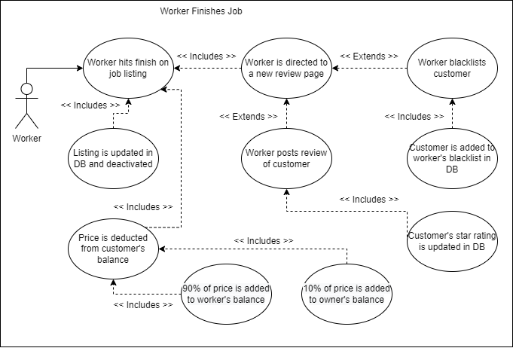

Participating Actor: Worker

Entry Conditions:

Worker is logged in

Worker has finished job

Exit Conditions:

Worker has reviewed the job

Worker has marked the job as finished, but not reviewed it

Event Flow

* 1. Worker marks job as finished
  2. System updates job as finished in database
  3. System Transfers amount out of Customer account
  4. System Transfers 10% to Owner account
  5. System Transfers 90% to Worker account
  6. System allows Worker option to provide feedback
  7. Worker Chooses rating and leaves feedback
  8. System posts review to database and updates Customer rating

Figure 7- Customer Provides Feedback for a Job and Tip

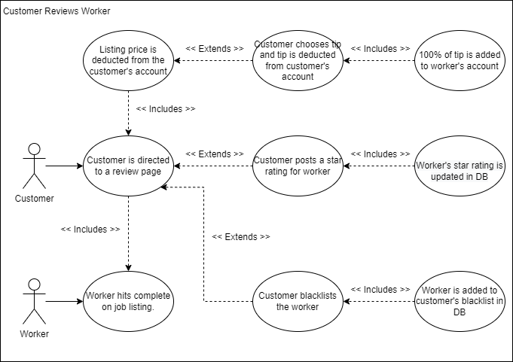

Entry Conditions:

Customer is logged in

Worker has marked job as finished

Exit Conditions:

Job is reviewed

Event Flow:

* 1. Customer finds Job
  2. Customer Chooses rating
  3. Customer leaves feedback
  4. System asks if Customer wants to leave a tip
  5. Customer chooses tip amount (Can be 0)
  6. System posts review to database
  7. System transfers tip to Worker
  8. System updates Worker rating

Figure 8- User Adds/Removes Money from Account

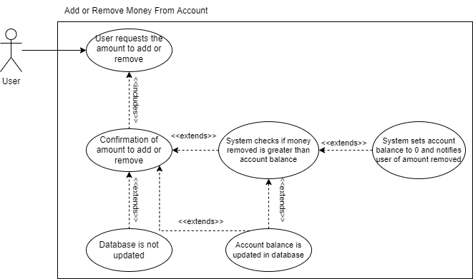

Participating Actor: User

Entry Condition:

User is logged in

User wants to add or remove money from their account

Exit Conditions:

Money is added or removed

User cancels action

Event Flow:

* 1. User requests an amount of money to add or remove
  2. System confirms amount to add or remove
     1. User accepts money addition or removal
     2. User cancels request
  3. System adds or removes money from account
     1. If the amount to remove is greater than or equal to account balance, System notifies User of the actual amount removed.
     2. If the amount is less than, System notifies User amount added or removed
  4. System displays new account balance